(Approx. 1890 words)

E-mail Strategy
By Dick Maybach, Member, Brookdale Computer Users’ Group, NJ
February 2018 issue, BUG Bytes
www.bcug.com
n2nd (at) att.net

Too often, when we find ourselves in unfamiliar technological territory, we adopt the first solution that works and ignore any alternatives. This is a good approach for tasks that we seldom perform, but less optimal for those we do every day, such as accessing our e-mail. In this article, we’ll step back from which keys we press and which icons we click to look at the e-mail forest. Once we entrust a message to our vendor, it’s beyond our control. The portions we can influence are the transferring of messages between our PC and the e-mail server. (For this article, I’ll use “PC” as a stand-in for “personal computer or hand-held device.)

There are two different ways to exchange messages between your PC and your e-mail server: (1) by webmail, where you access messages on your vendors website using a browser or (2) by using a client e-mail program on your PC, which transfers the messages to and from the server.

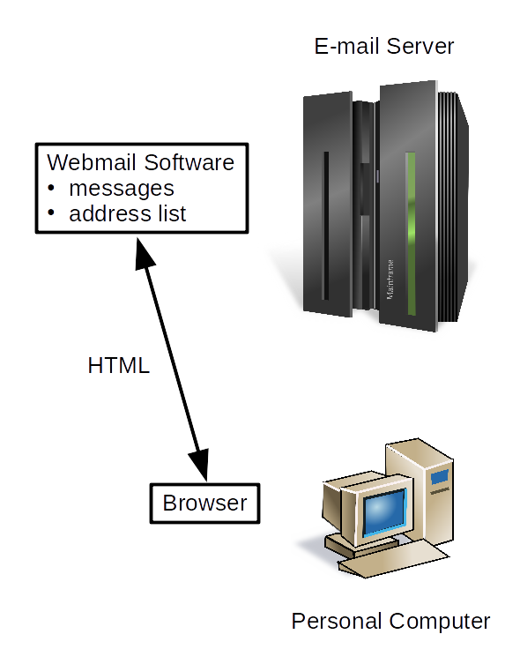
Figure 1. E-mail Using Webmail

As Figure 1 suggests, when using webmail all your messages as well as your address list are stored only on the server. You must do something explicit to copy this information to your PC. Webmail requires no setup, except for making the vendor's URL a favorite, and minimizes the resource use on your local device. You use your browser, which communicates with the vendor using the same HTML protocol as for any website. All the e-mail-specific software runs on the vendor’s site, which also stores all the associated data.

- You usually have only a limited selection of interfaces you can use to access your e-mail.
- The supported services may be limited.
- You need Internet access to see your mail and access your address list.
- If encryption is available it's less secure as you send the unencrypted file and rely on the vendor to encrypt it.
- Since the vendor stores your e-mail as well as your address list, moving to a new vendor is cumbersome, and transferring the stored data may be difficult or impossible.

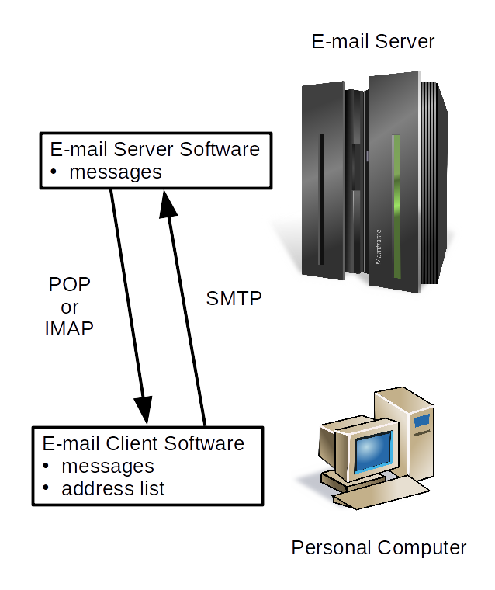
Figure 2. E-mail Using Client Software.

A client e-mail program runs on your PC, as shown n Figure 2, and usually stores some or all your messages and your address list locally, and it must be properly configured. Although the figure shows your messages stored on both the server and your PC, this is not always true. Depending on how you’ve configured the server and your client, they may appear on only one of these. However, your address list resides only on your PC.

- This approach requires that you configure the client, but most can do this automatically. You have only to enter your e-mail address and password for the client to set up the send and receive protocols. You do have to be sure that the defaults reflect your preferences.
- If the automatic configuration fails, you will need the URL of the POP or IMAP server and the URL of the SMTP server. This information is usually available on your server's website.
- Once set up, the client will periodically check the server for new messages and will download them and alert you, assuming of course you are connected to the Internet.
- Many clients offer additional services, such as encryption, automatic sorting of messages into folders, SPAM filtering, automatic capturing of e-mail addresses, and calendar functions.
- Encryption is more secure, as it takes place on your equipment, before you send the result to the vendor.
- Your messages may be stored only on your local device. This means they are accessible even if you don’t currently have an Internet connection, but it also means you must back up the data.

POP is the older protocol, dating from 1985, a time when storage on servers was dear. As a result, the early implementations deleted messages from the server immediately after they were downloaded. Now, some vendors give you the option of this deletion; moreover, it can be set differently for each PC. I find it convenient not to delete messages when I download them to a laptop but to delete them when I download them to my desktop. This keeps my server clean, allows me to use e-mail when I travel, and stores my e-mail history on my desktop, which I back up regularly. In preparing this article, I found several Internet articles that claimed that POP e-mail was always deleted from the server when it was read and concluded that POP was not practical if you used more than one PC. This may be true for some vendors and when using some e-mail clients, but it certainly isn’t for my vendor, AT&T (who farms out their e-mail to Yahoo), and my client, Thunderbird.

IMAP does not delete messages unless you explicitly do so. Although some clients, in particular those running on hand-held devices, may not include attachments when they download messages, or may retain messages for only a limited time. Neither is true for the e-mail vendors and PC clients I use and the way I have them configured. Microsoft uses their own protocol, Microsoft Exchange or MAPI, most commonly used with Hotmail, but I have no experience with it.

Many vendors offer both POP and IMAP, and indeed you may find that you can use both on a single e-mail account. Thus, you can choose the one that works best with each particular device. For AT&T e-mail I use POP on my desktop and laptops and IMAP on my smartphone.

Regardless of the protocol to download messages, you almost certainly use Simple Mail Transfer Protocol (SMTP) to upload them. As its name implies, you probably won’t have to configure this.

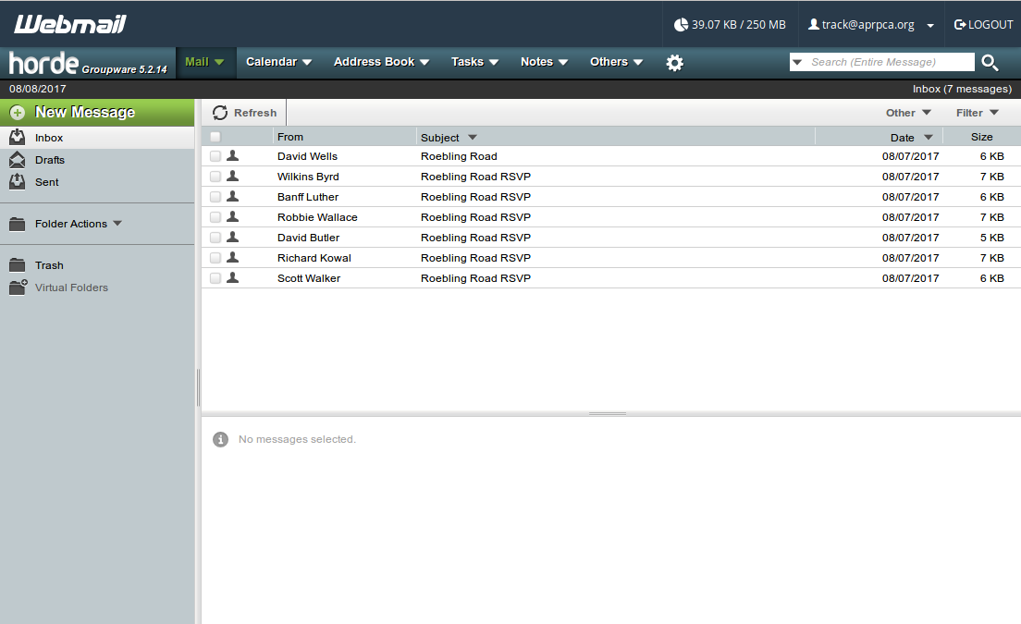
Figure 3. Webmail Window.

Figure 3 shows accessing e-mail using webmail. I use a client for this account, and as a result there isn’t much customization here. Otherwise, I would probably have set up several folders in addition to Inbox, Drafts, and Sent shown. As you can see from the menu bar at the top, this vendor offers additional services, including calendar, address book, note, and task management.
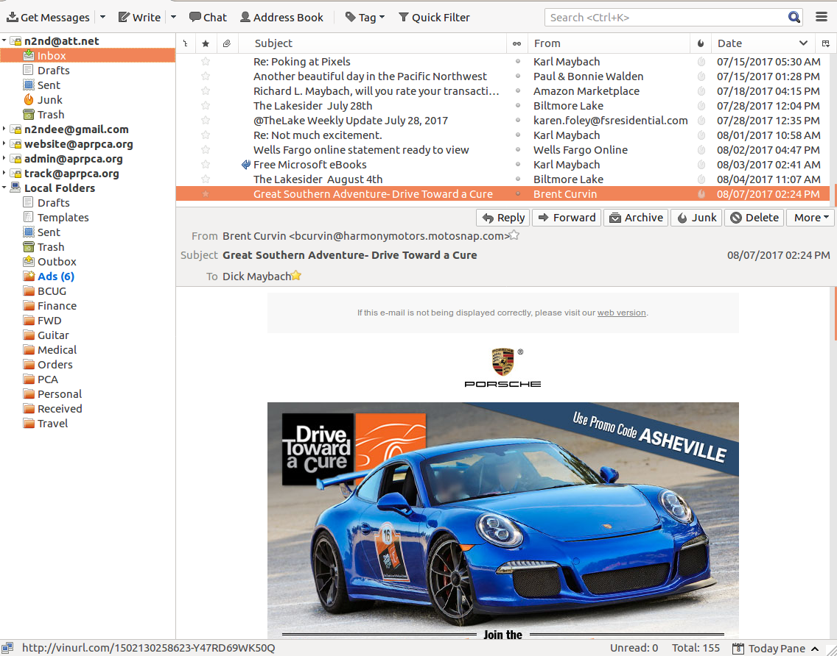
Figure 4. E-mail Client Window.

Figure shows the Thunderbird client, http://www.mozilla.org/en-US/thunderbird/, which I how I access all my mail, five accounts, as you can see in the left sidebar. One of these (AT&T) uses POP, and the other IMAP. Every 10 minutes each account is checked for new messages, and a desktop icon tells me if there are any I haven’t read. There are four folders on the server, Drafts, Sent, Junk, and Trash. (Although Inbox appears to be on the server, in fact it resides on my PC.) I have also defined several local folders to organize my mail. Two, Ads and FWD, are interesting. Thunderbird allows the creation of filters, and I’ve set up one to immediately send any message whose subject begins with “Fwd:” to the FWD folder. I’ve found that these are seldom important and prefer that they not clutter my inbox. Similarly, I’ve defined several filters to send all messages from specific addresses to the Ads folder, which contained six unread messages when I made this screen-shot. These aren’t spam, as I do business with these folks, but again the messages aren’t vital, and I prefer that they not obscure more important ones. It’s not evident from the shot, but Thunderbird also provides calendar, task management, and encryption services. Like its relative Firefox, there are dozens of add-ons available to add more features.

Privacy is a concern any time you interact with the Internet and especially so with e-mail. Someone with access to your message history probably knows where you live, the make of your car, the name of your bank, the names and addresses of your relatives and friends, your vacation habits, the vendors with whom you deal, and many other details of your personal life. Would you be comfortable if this information were given to a criminal? The leaks that make headlines are ones where the stolen data is made public; we don’t hear about the ones where it is quietly sold. Think about this before you again say, “I have nothing to hide.” To reduce the damage should your account be compromised, you should periodically delete your old messages from their server. (This assumes you have copies on your PC; if not, you’ll just have to be comfortable with the risk.) Here is the procedure.

- Access your account using webmail. (You may be able to delete server files using a client with POP but check that this is so for your case before you rely on it. You almost certainly can’t delete them with a client using IMAP.)
- Delete the files in every folder (inbox, sent, drafts, trash, etc.).
- Again, using webmail, check back in a day or so to be sure the files are gone. (One of my vendors, doesn’t actually delete the files, but just marks them for future deletion.)
(A far better method of preserving privacy is to encrypt your messages, but in almost 40 years of using e-mail, I’ve only convinced two people of this.)

Finally, if you use an e-mail client, look carefully at its defaults. Initially my vendor’s POP server deleted my messages after I downloaded them, but when I deleted them on my PC, Thunderbird helpfully sent them back to the server’s delete directory. Similarly, I had to change the repository of sent messages from the server to the local sent directory on the PC. Exploring the directories on your server using webmail will show if you have similar problems.

There are several factors that affect the choice of using webmail or an e-mail client to access your messages.

- With webmail, you rely on your vendor to store both your messages and address list, leaving both vulnerable to hacking. This also makes it difficult to change vendors without losing these data.
- Webmail is easier to set up than is a client, which must be properly configured.
- A client makes accessing multiple e-mail accounts much easier.
- If you use a client, you must still periodically check your account using webmail to delete unwanted messages.
- Since a client stores your messages and address list locally, you are responsible for their back up, as well as for moving the data should you get a new computer.
- Changing to a different client program means you may not be able to move some or all of your data to it. (I’ve had good luck moving address lists, but less moving messages. Fortunately, old e-mail is usually not valuable.)

The choice between POP and IMAP is usually not very important; however, check with the vendor to be sure the features you need are available with the choice you make.

- POP can offer better privacy protection, if it’s set up to delete messages from the server as they are downloaded.
- If the vendor has implemented POP so that it’s not possible to download a message without deleting it from the server, the account is usable from only one device.
- If IMAP does not download attachments with their messages, you must always have Internet access.
- With IMAP you will certainly have to visit the server periodically using webmail to delete old messages. This may not be needed with a POP account, but you must check.

